**Introduction**

Possible points to include (from tri-societies presentations):

Cover crops are a potential biological mode of action for controlling weeds in corn-soybean crop rotations that may also reduce herbicide costs for producers. However in this region, the cropping systems and climate constrain cover crop biomass production in a way that is not optimal for maximizing cover crop benefits. The degree to which cover crop type, fall planting date and spring termination method impact cover crop efficacy on weed control remains poorly understood. The quantity of cover crop biomass needed for effective weed control is also poorly understood. Therefore we conducted a meta-analysis to understand the impact of cover crops, and their management, on weed control in corn-soybean crop rotations in the Midwestern Corn Belt.

**Methods**

Database search

We conducted a systematic search of relevant literature using ISI Web of Knowledge (WoS,

available online). A literature was conducted in October 2018 using the following Boolean string: (weed* AND ("cover crop*" OR "green manure" OR "catch crop*") AND ("corn" OR "maize" OR "soybean*")). This resulted in a total of 676 studies that were screened for eligibility based on the following criteria: a.) studies must have been conducted in one of “Corn Belt” states, which were included because they represent contiguous states in the region with generally the largest acreage of corn acres harvested in the most recent five years of available data (USDA-NASS 2019); this includes Illinois, Indiana, Iowa, Kansas, Michigan, Minnesota, Missouri, Nebraska, North Dakota, Ohio, South Dakota, and Wisconsin, b.) studies must have measured weed biomass and/or weed density, and c.) studies must have included a treatment that tested the effects of a winter cover crop planted prior to either corn or soybean against a treatment that included no over-wintered cover crop. From this search, we screened the full text of 220 articles for inclusion in the database, where the majority were eliminated based on initial review indicating that they were not relevant based on abstract and title because they did not include weed measurements or did not have the appropriate experimental design. From these remaining articles, 15 fit our criteria representing 233 distinct response ratios.

Database development

Management information was extracted systematically from each experiment. Extracted data included information pertaining to publication date, geographical location, soil characteristics, and cash/cover crop management choices, such as cash and cover crop selection, tillage system, cover crop termination method, and cash/cover crop planting date and density (note: we will need to explain more detail about the different groupings of these categories). Our response variables of interest, weed biomass and density, were extracted from paired comparisons of measurements taken in the same crop, with or without the presence of an over-wintered cover crop, where all other aspects of management were the same. Where provided, cash crop yield and cover crop biomass were also extracted from experiments.

Mean annual precipitation, mean annual temperature, and aridity index, an integrated measure of temperature, precipitation and potential evapotranspiration were derived from location coordinates using the CGIAR-CSI Global-Aridity and Global-PET databases (Zomer et al. 2008).

Statistical analysis

Response ratios were created as the ratio of weed density or weed biomass in the cover crop treatment divided by the no cover crop treatment (citation). Thus far we have performed an unweighted meta-analysis because most studies either did not report variances for weeds and many had similar numbers of replications. Response ratios were grouped, where possible, by site-year-treatment only if they reported data in this way. If data was reported as averages across years or treatments they were captured this way in the response ratios. We used a mixed effects model that accounted for the random effect of study, analyzed with the LME4 package in R.

**Results & Discussion**

Underline are possible sections to include

Italics are possible figures and tables to include

Database overview

We located fifteen articles that fit our criteria, representing 123 response ratios for weed biomass and 110 response ratios for weed density.

*Figures/Tables: Table of studies, map (F1)*

|  |  |  |  |  |
| --- | --- | --- | --- | --- |
| State | Cover crop species | Season of weeds measurement | Crop following cover | Reference |
| IL | cereal rye, vetch | summer | soybean | Davis (2010) |
| WI | cereal rye | summer | soybean | Bernstein et al. (2011) |
| MN | cereal rye | summer | soybean | De Bruin et al., 2005 |
| MI | mogul medic, red clover, berseem clover, santiago medic | spring | corn | Fisk et al., 2001 |
| MN | cereal rye | spring | soybean | Forcella 2013 |
| IA | winter wheat/winter pea, cereal rye/vetch | summer | soybean | Delate et al. 2012 |
| OH | winter wheat, hairy vetch | summer | soybean, corn | Gallagher et al., 2003 |
| MN | radish | summer | corn | Gieske et al., 2016 |
| OH | hairy vetch | summer | corn | Hoffman et al. 1993 |
| IN | winter wheat, annual rye grass | fall | corn, soybean | Mock et al., 2012 |
| NE | cereal rye | spring | corn | Werle et al., 2017 |
| IL | radish, canola, rye | summer | soybean | Crawford et al., 2018 |
| MO | austrian winter pea, hairy vetch, crimson clover, oilseed radish, winter oat, italian ryegrass, rye + vetch, rye, winter wheat | spring | soybean | Cornelius and Bradley, |
| KS | winter wheat | summer | corn | Currie and Klocke, 2005 |
| NE | barley, cereal rye, triticale, wheat, vetch | summer | soybean | Williams et al., 1998 |

Differences in weed biomass vs. weed density

Experiments show that cover crops are generally more effective at reducing weed biomass (size of weeds reduced in 95/123 response ratios or 77%) compared to weed density (amount of weeds reduced in 62/110 response ratios or 56%). This suggests that cover crops may be more beneficial from the standpoint of controlling the size of weeds rather the amount of weeds. This finding may have important implications for the efficacy of other weed management approaches, such as herbicide programs or mechanical approaches; if cover crops can reduce the size of weeds, this is rationale for their inclusion in an integrated weed management approach.

Timing of measuring weeds seems to have an important effect. It appear that the most of the negative response ratios are from the measurements taken in spring versus summer (>6 weeks from cover crop termination). Preliminary stats shows a significant difference between the groups for both weed density and weed biomass. This is something to explore in more detail. We are really not seeing an effect on weed density for any of the variables. But timing could be the key.

It is interesting to note that there were a number of experiments where cover crops led to an increase in weed density, counter to what we anticipated we might find. In general there are several possible explanations for why this occurred. It is possible that interactions with the cover crop biomass and herbicides applied for weed control and/or cover crop termination reduced product efficacy. It is also possible that for a variety of reasons the cover crop treatments created a more favorable environment for weeds (i.e. soil moisture retention). Most all of the experiments included in this analysis note in their rationale that weed control with a cover crop was an explicit goal of their experiments, so we can assume that experiments were designed to see reductions in weeds by including a cover crop.

*Overall distribution separated by biomass and density (F2) – could color code this by season of measurement*

|  |  |
| --- | --- |
|  |  |

Termination method

Updated database does not show significant differences between termination methods groups for either weed biomass or weed density. Figures suggest that herbicides were the most effective termination method for reducing weed biomass, which could be different from the effect herbicides have on weed density but per seedling biomass would be less. Previously we had been describing this as: experiments that used herbicides or a combination of herbicides and mowing to terminate, or cover crops that were winter-killed were found to be more effective at weed control than cover crops terminated solely by crimping or mowing. In particular DeBruin found two glyphosate applications to be the most effective termination method. Evidence from studies in the southeast suggests that herbicides applied later in the season or with residual action were most effective at weed control in tandem with cover crops (Norsworthy et al. 2016; Wiggins et al. 2014; Montgomery et al. 2018).

*Figure of distributions broken out by termination method (F3)*

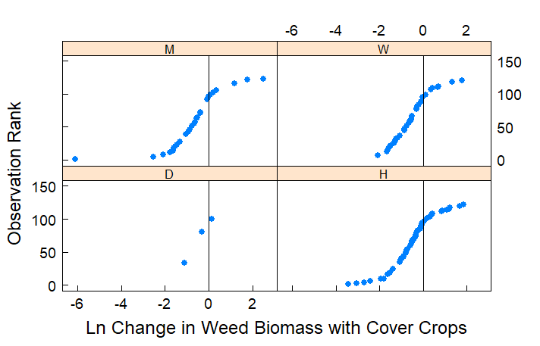

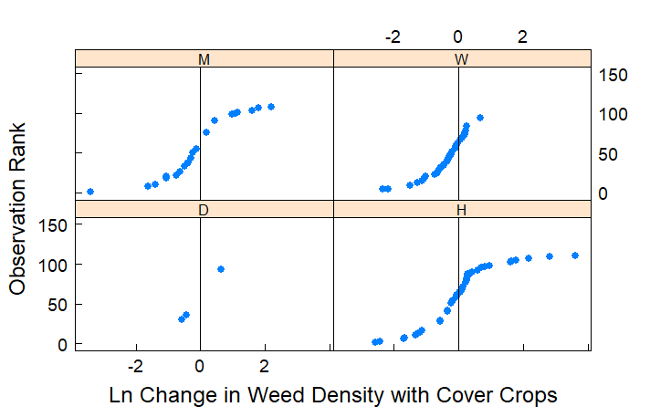

Biomass production

When a cover crop preceded corn, cover crop biomass of approximately 4000 kg ha-1 tended to consistently reduce weed biomass and weed density. When a cover crop preceded soybean, results in our analysis were variable; some experiments showed significant weed control with smaller amounts of cover crop biomass (<1000 kg ha-1), while others had ineffective weed control with smaller or larger amounts of cover crop biomass before soybean.

*Regression type figure of response ratios by biomass, could be sorted by crop following or cover crop species or both (F4)- note that if we include a regression line it not a good idea to include groups beyond the two panels*

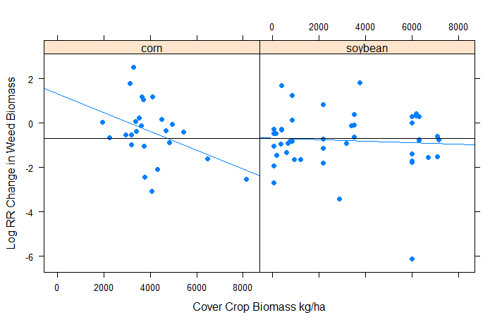

Cover crop species

Experiments included in our analysis utilized grass, legume and mixed cover crop species. We did not find differences in the efficacy of weed density control with different cover crop species, but did see a significant difference in cover crop species for weed biomass control (when analyzing type as a fixed effect in our mixed effects model, to be clear).

*Figure of distributions broken out by cover crop species (F5 – if not included in F4). This mostly looks like the same trend as F2 will show –weed biomass is better controlled with cover crops than weed density. The stats results suggest that grass cover crop species are more effective at reducing weed biomass.*

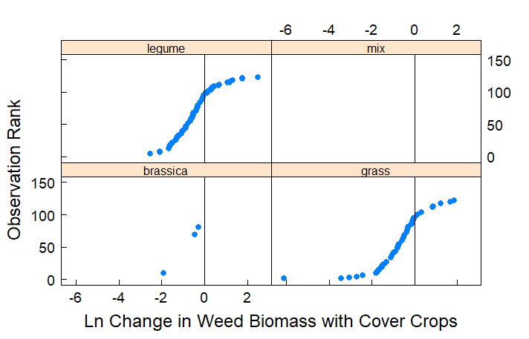

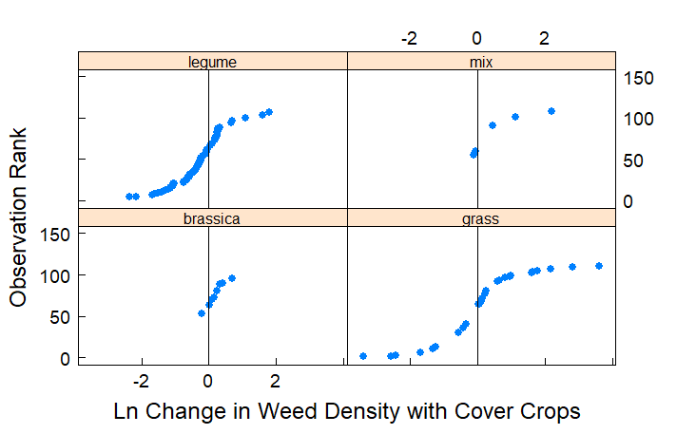

Crop following the cover crop – from here down still needs to be updated w/ new database info

Maybe no new figure here if included in F4

Crop yields

When experiments included yields we found that cover crops represented “win-win” scenarios 18% of the time, where weeds were reduced and yields were increased. “Lose-lose” situations (weeds increased and yield decreased) represented 46% of possible response ratios. Our analysis confirms other work that corn following a cover crop in the North Central region can decrease yields (Miguez and Bollero 2005; Marcillo and Miguez 2017). Note that these numbers need to be updated with the new database info.

*Figure: Win-Win plot (F5 or F6)*

Weather variables

Need to add more if this turns out to be something interest

Organic experiments

There were four organic experiments in the database and they were less effective at controlling weeds and improving yields; none of those response ratios fell into the win-win category.

*Figure: Possible win win plot just for organic experiments, or distribution of these studies together*

Other potential discussion points:

Community of weeds vs individual weed species?

Is the method of planting stimulating weeds?

Possible long term weed seed bank changes with a cover crop

Management of herbicide resistant weeds

CC biomass relationship to yield